**Module Four**

**CURRENT ELECTRICITY**

**4.0 Introduction**

The study of electric charge can be divided into two categories: static electricity and current electricity. We dealt with static electricity in in the first three modules. In this module, we will discuss current electricity. ***Electric current is a flow of electric charge through a conductive medium***. In electric circuits, this charge is often carried by moving electrons in a wire. It can also be carried by ions in an electrolyte, or by both ions an electron such as in plasma. The S.I. unit for measuring the rate of flow of electric charge is the **ampere**, *which is charge flowing through some surface at the rate of one coulomb per second.* Electric current is measured using an ammeter.

**4.1 Electric Current**

The **electric current** is defined as the charge $(∆Q)$ passing through a given cross-sectional area A of a wire per unit time, that is,

$$I=\frac{⩟Q}{⩟t}- - - - - - - - -4.1$$

The unit of current is Coulomb per second, which is called ampere (A). As $∆t→0$, Equation 4.1 may be written in differential form as

$$I=\frac{dQ}{dt}- - - - - - - - - - 4.2$$

Which implies,

$$Q = \int{Idt}+ c$$

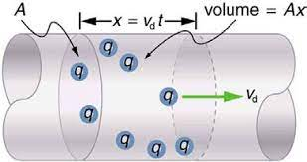

Figure 4.1: Current flowing through a conductor

As shown in figure 4.1, total charge Q that passes through area A in a time t is

$$Q= qnAv_{d}t- - - - - - - - 4.3$$

where n = number of charges *q* per unit volume and $v_{d}$ = drift velocity of the charges from Equation 4.1 we have, Note that, the Electric current does not depend on time.

$$I= \frac{Q}{t}=qnAv_{d}- - -- - - 4.4$$

The **current density** is defined as electric current per unit cross-sectional area. For a uniform current flow, we have,

$$J = \frac{I}{A}= {qnv}_{d}- - - - - 4.5$$

The S.I. unit of J is ampere per meter square ($Am^{-2}$). From Equation 4.5, the current density, like the current, is in the direction of charge motion for positive charge carriers and opposite the direction of motion for negative charge carriers.

**4.2.** **Ohm’s Law**

A current density and electric field are established in a conductor or whenever a potential difference is maintained across a current carrying conductor. This means that the current density is directly proportional to the electric field as given in equation 4.6

$$J∝E$$

$$J=σE- - - - - -4.6$$

Where $σ=$ 𝐶𝑜𝑛𝑑𝑢𝑐𝑡𝑖𝑣𝑖𝑡𝑦 𝑜𝑓 𝑡ℎ𝑒 𝑚𝑎𝑡𝑒𝑟𝑖𝑎𝑙 and E is the electric field intensity.

***Ohm’s Law states that for many materials, the ratio of current density to the electric field is a constant 𝜎 that is independent of the electric field producing the current.***

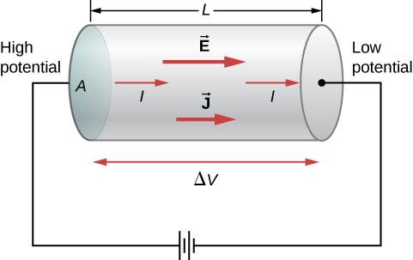

Figure. 4.2 Current flowing through a conducting material.

As shown is figure 4.2, If we consider a segment of a straight conducting wire of uniform cross-sectional area A and length $dl.$ Then the an electric field emanated with a potential different of

$$∆V=V_{b}-V_{a}=El$$

$$E=\frac{∆V}{l}- - - - - - -4.7$$

Also if the current density

$$J=σE=\frac{σ∆V}{l}$$

$$\frac{σ∆V}{l}=\frac{I}{A}$$

so the pd. across the conducting wire

$$∆V=\left(\frac{l}{σA}\right)I=RI- - - - - - -4.8$$

The quantity is called the Resistance of the conducting wire which has a unit of 𝑉/𝐴

***Ohm’s law states that under constant physical conditions, the current in a conducting wire is proportion to the potential difference V applied to its ends***. That is,

$$V∝I$$

Which implies

$$I=\frac{V}{R}- - - - - - -4.9$$

It is found experimentally that the resistance R of a wire is proportional to the length of the wire and inversely proportional to the cross-sectional area A, that is it depends on the geometry and symmetry of the conducting material.

$$R ∝\frac{L}{A}$$

$$R=ρ\frac{L}{A}- - - - - - 4.10$$

$W$ here $ρ$ is the constant of proportionality which is known as the **resistivity** of the material. The resistivity $ρ$ depends only on the material and the temperature. The unit of resistivity $ρ$ is ohm-metre ($Ωm$).

**Conductivity**, $σ$, is the reciprocal of the resistivity, that is

$$σ =\frac{1}{ρ}- - - - - - 4.11$$

The conductivity $σ$ has units of ${\left(Ωm\right)}^{-1}$.

It as be shown that current density $J = σE$ from equation 4.6 is another form of Ohm’s law. The resistivity of all materials depends on temperature. For metals, the resistance usually increases with increasing temperature while the resistance of semiconductors and insulators decreases with increasing temperature.

**Ohmic conductors** are conductors that obey Ohm’s law. For example, copper and tungsten obey Ohm’s law. In this type of conductors, the current *I* is reversed in direction when the p.d. V is reversed but the magnitude of *I* remains unchanged. So the characteristic or I-V graph is a straight line passing through the origin as shown in Figure 4.3.

**Non-ohmic conductors** are those which do not obey Ohm’s law. For example, junction diode, neon gas, diode valve, dilute H2S04 (platinum electrodes) do not obey Ohm’s law. A non-ohmic characteristic or I- V graph may have a curve instead of a straight line; or it may not pass through the origin. A non-ohmic conductor may conduct poorly or not at all when the p.d. is reversed (-V).

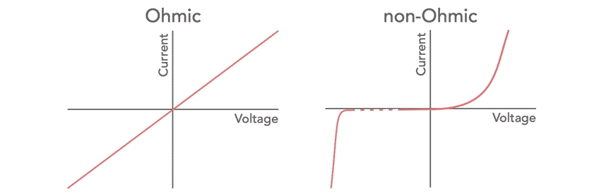

Figure 4.3 illustrates the non- ohmic characteristics of some conductors.

**4.4 Electric Conductor**

Due to the quantum mechanical nature of electrons, a full simulation of electron movement in a solid (i.e. conduction) would require consideration of not only all the positive ion cores interacting with each electron, but also each electron with every other electron. **Electrical conduction** is the movement of electrically charged particles through a transmission medium. The movement can form an electric current in response to an electric field.

Under the application of a field, E, electrons experience a force that is $qE$, and thus an acceleration from $F=ma and F=qE$

then,

$$a=\frac{qE}{m}-------- 4.12$$

From the equation of motion, an electron emerging from a collision with velocity $u$, the velocity after time t is given by:

$$v=u+at=u+\frac{qEt}{m}- - - - - - -4.13$$

if the electrons are scattered randomly by each collision, $u$ will be zero. If we also consider the time t = τ, an equation for the drift velocity is given:

$$v_{d}=\frac{qEτ}{m}- - - - - - - - 4.14$$

Where $τ$ is the average time interval between successive collisions. The $τ$ value of depends on the size of the metal atoms and the number of electron per unit volume.

When an electric field is applied, the free electron drift slowly in a direction opposite that of the electric field, with an average drift speed $v_{d}$ that is much smaller than their average speed between collisions Additionally, the electrons move in straight lines, do not interact with each other, and are scattered randomly by nuclei.

1. The electron’s motion after a collision is independent of its motion before the collision.
2. The excess energy acquired by the electron in the electric field is lost to the atom of the conductor when the electron and atom collide



For ***n*** free electrons per unit volume, the current density *J* is

$$J=nqv_{d}=\frac{nq^{2}E}{m}τ- - - - - - - - 4.15$$

Also form Ohms Law, $J=σE$

$$σ=\frac{nq^{2}}{m}τ- - - - - - -4.18$$

$$ρ=\frac{1}{σ}=\frac{m}{nq^{2}τ}- - - - - - - - -4.17$$

Note that: the conductivity and resistivity do not depend on the strength of the electric field

**4.5 Resistors in Series and in Parallel**

***In Series:***

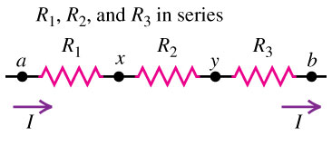

Figure 4.5 Resistor in series

1. The same current flows through all resistors in series
2. Total potential difference = sum of individual potential differences
$$V_{T}=V_{1}+V_{2}+V_{3}+…+V_{n}- - - - - - - - 4.18$$

3. Individual potential differences are directly proportional to individual resistances
$$V_{1}= IR_{1}, V_{2}=IR_{2} and V_{3}=IR_{3}- - - - -4.19$$

4. Total resistance, $R_{eq}$ = sum of individual resistances

$$R_{eq}=R_{1}+R_{2}+R_{3}+…+R_{n}- - - - - - -4.20$$

***In Parallel:***

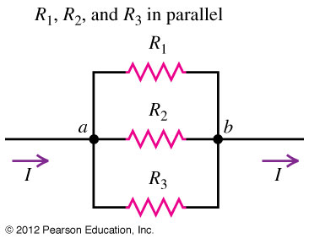

Figure 4.6. Resistor in parallel

1. Total current, $I_{T}$ equal to sum of individual currents flowing through the resistors in Parallel.

2. The potential difference across each resistor is the same and is equal to the full voltage V.

3. Individual current is inversely proportional to individual resistances

4. Total resistance, Req is given as

$$\frac{1}{R_{eq}}= \frac{1}{R_{1}}+ \frac{1}{R_{2}}+ \frac{1}{R_{3}}+…+\frac{1}{R_{n}}- - - - - - 4.22$$

**4.6. Resistance and Temperature**

The resistivity of a metal varies linearly with temperature according to the expression

$$ρ= ρ_{o} \left[1+α\left(T-T\right)\right]- - - - - - 4.23$$

Where 𝜌 is the resistivity at a temperature *T* (in degrees Celsius), $ρ_{o}$ is the resistivity at some reference temperature To and α is the temperature coefficient of resistivity. Equation 4.23 can also be written as

$$α= \frac{1}{ρ_{o}}\frac{ρ-ρ_{o}}{T-T_{o}}= \frac{1}{ρ_{o}}\frac{∆ρ}{∆T}$$

Because resistance is proportional to resistivity, we can also have

$$R= R_{o} [1+ α\left(T-T_{o}\right)]- - - - - - -4.24$$

**Definition** – The resistance thermometer or resistance temperature detector (RTD) uses the resistance of electrical conductor for measuring the temperature. The resistance of the conductor varies with the time. This property of the conductor is used for measuring the temperature.

The metal has a high-temperature coefficient that means their temperature increases with the increase in temperature. The carbon, platinum and germanium have low-temperature coefficient which shows that their resistance is inversely proportional to temperature.

The resistance versus temperature curve is shown in the figure 4.7 below. The curves are nearly linear, and for small temperature range, it is very evident.

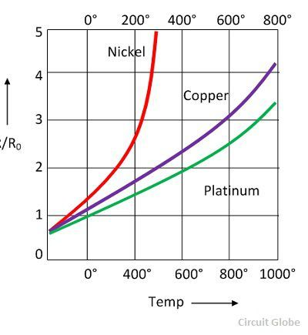

Figure 4.7. Resistance versus temperature curve of some metals

The following are the requirements of the conductor used in the RTDs.

1. The resistivity of the material is high so that the minimum volume of conductor is used for construction.
2. The change in resistance of the material concerning temperature should be as high as possible.
3. The resistance of the material depends on the temperature.

**4.7 Electromotive force and Circuit**

**The electromotive force or e.m.f.** is the potential difference across the terminals of a battery (or any other generator) on open circuit, that is, when no current is flowing. The e.m.f. of a battery depends on the nature of the chemicals used and not on its size. However, the internal resistance, *r*, of the battery depends on the size of the battery.

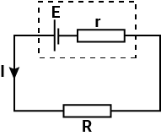

Figure 4.8.

A battery of e.m.f. *E* and internal resistance *r* is joined to an external resistor ***R***, and a current *1* flows when key *K* is closed. The p.d. across *R* is *IR* and the p.d. across *r* is *Ir*. So

$E = IR + Ir = l(R + r)$ Or $I = \frac{E}{R+r}-----4.25$

**Internal Resistance and Terminal Voltage**

The amount of resistance to the flow of current within the voltage source is called the internal resistance. The internal resistance r of a battery can behave in complex ways. It generally increases as a battery is depleted, due to the oxidation of the plates or the reduction of the acidity of the electrolyte.

However, internal resistance may also depend on the magnitude and direction of the current through a voltage source, its temperature, and even its history. The internal resistance of rechargeable nickel-cadmium cells, for example, depends on how many times and how deeply they have been depleted.

The terminal voltage of the battery depends on the emf, the internal resistance, and the current, and is equal to

$$V = E–Ir- - - - - - 4.26$$

Equation 4.26 gives the terminal p.d. when the battery e.m.f. maintains the current. Suppose, however, that a current is passed through a battery in opposition to its e.m.f., as shown in Figure 4.8. For a given emf and internal resistance, the terminal voltage decreases as the current increases due to the potential drop $Ir$ of the internal resistance.

**4.8 Electrical Power and Efficiency**

Power is a measure of how quickly energy is transferred. Efficiency is a measure of how much useful energy or power is transferred. By considering where energy is ‘wasted’ we can improve efficiency. The electrical work required to transfer a charge q through a potential difference V is given by

$$W=qV- - - - - - - - 4.27$$

If *q* is measured in coulombs (C) and V is measured in volts (V), then the unit of W is joules (J). The electrical power delivered by an energy source is defined as the rate at which electrical energy is being done, that is,

$$P= \frac{ElectricalWork}{Time}= \frac{qV}{t}=VI- - - - - - -4.28$$

Since $I=\frac{q}{t}$, where *i* is current in ampere.

Equation 4.28 can be expressed in the following ways:

$$P = IV, P =\frac{V^{2}}{R}, P=I^{2}R- - - - - - -4.29$$

The unit of power is watt ($1W = 1J/s).$

We can also define the e.m.f. E of a battery or any other generator as the total energy per coulomb it delivers round a circuit joined to it. If a device of e.m.f. *E* passes a current *1* for a time *t*, then the charge it circulates is $Q$ = *It*. From the above definition of e.m.f. *E,* the total electrical energy liberated is,

$$W = QE = IEt- - - - - -4.30$$

and total electrical power generated is

$$P=\frac{W}{t}=EI- - - - - - -4.31$$

Efficiency, $η$, of a circuit is the ratio of the power output to the power generated:

$$η= \frac{Power output}{Power generated}- - - - - - 4.32$$

$$η= \frac{P_{out}}{P_{gen}}=\frac{IV}{IE}= \frac{V}{E}- - - - - - -4.33$$

Using Equation 4.25,

$$η= \frac{R}{R+r}- - - - - - - -4.34$$

This shows that Power output of R is a maximum when.

* 1. **Problem-Solving Strategies for Series and Parallel Resistors.**

1. Draw a clear circuit diagram, labeling all resistors and voltage sources. This step includes a list of the knowns for the problem, since they are labeled in your circuit diagram.
2. Identify exactly what needs to be determined in the problem (identify the unknowns). A written list is useful.
3. Determine whether resistors are in series, parallel, or a combination of both series and parallel. Examine the circuit diagram to make this assessment. Resistors are in series if the same current must pass sequentially through them.
4. Use the appropriate list of major features for series or parallel connections to solve for the unknowns. There is one list for series and another for parallel. If your problem has a combination of series and parallel, reduce it in steps by considering individual groups of series or parallel connections, as done in this module and the examples. Special note: When finding *R*, the reciprocal must be taken with care.
5. Check to see whether the answers are reasonable and consistent. Units and numerical results must be reasonable. Total series resistance should be greater, whereas total parallel resistance should be smaller, for example. Power should be greater for the same devices in parallel compared with series, and so on.

**References**

**Adewale OA.** (2020) Physics for University Beginners. Volume One. Unilag Press. Lagos, Nigeria

**Akintunde OA** (2020). Wordnota Solution Physics Practice Text.

**Giambattista A, Richardson B and Richardson RC** (2010) College Physics. Boston: McGraw Hill Higher Education

**Halliday D Resnick R and Walker J** (1997) Fundamental of Physics. New York: Wiley and Sons

**Jewett J and Serway RA** (2008). Physics for Scientists and Engineers. Bemount: Thompson Higher Education

**Uzomah Odua** (2018) Physics Review.